**MWD CYBERGUARD BUSINESS PLAN**

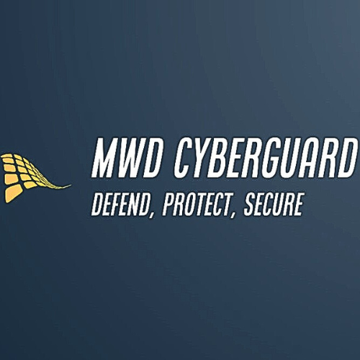

1. Executive Summary

MWD CyberGuard is a cybersecurity monitoring and auditing firm focused on providing high-quality cyber protection services for businesses across various sectors, including healthcare, finance, utilities, and government. With a mission to safeguard digital assets, ensure compliance, and mitigate risks through advanced security solutions and expert consulting, we aim to become a trusted partner for organizations looking to secure their operations against cyber threats.

2. Business Description

MWD CyberGuard offers a comprehensive range of cybersecurity services designed to protect digital infrastructure and sensitive data. Our services include risk assessment, security audits, 24/7 monitoring, incident response, and more. We strive to be the first choice for businesses needing reliable and effective cybersecurity solutions.

3. Market Analysis

* Target Customers: Our primary customers include hospitals, hotels, casinos, banks, financial institutions, schools, airlines, small businesses, utilities (gas, petroleum, energy), communication sectors, defense, internal security groups, and government agencies.
* Market Size and Potential: The global cybersecurity market is rapidly growing due to increasing cyber threats. Sectors like healthcare and finance are particularly vulnerable, highlighting the need for robust security measures.
* Competitors: Key competitors include other cybersecurity firms, in-house security teams, and managed security service providers (MSSPs).

4. Services Offered

* Risk Assessment and Management
* Security Audits and Compliance
* Vulnerability Assessment and Penetration Testing (VAPT)
* 24/7 Security Monitoring and Incident Response
* Security Information and Event Management (SIEM)
* Network Security Management
* Endpoint Security
* Application Security
* Cloud Security
* Data Protection and Privacy
* Security Awareness Training
* Business Continuity and Disaster Recovery Planning
* Identity and Access Management (IAM)
* Threat Intelligence and Analytics
* Security Policy and Procedure Development
* Consulting and Advisory Services

5. Marketing Strategy

* Customer Acquisition: Utilize digital marketing, attend industry conferences, network with business associations, and offer free initial consultations.
* Retention Strategy: Provide exceptional service, conduct regular check-ins, offer loyalty programs, and provide ongoing training and updates.
* Branding: Develop a strong brand identity through a professional logo, website, and promotional materials.

6. Operational Plan

* Location: Start with a central office and expand to additional locations as the business grows.
* Staffing Needs: Initially hire a small team of experienced cybersecurity professionals, including analysts, auditors, and support staff, with plans to expand as needed.
* Day-to-Day Operations: Offer continuous monitoring and response services, conduct regular audits, manage client communications, and stay updated on cybersecurity trends and threats.

7. Financial Plan

* Startup Costs: Initial investment required for office setup, technology infrastructure, hiring, marketing, and legal compliance.
* Revenue Model: Charge for services on a subscription basis, offer tiered service packages, and provide consulting on an hourly or project basis.
* Projected Earnings: Aim for steady growth by targeting key clients in the first year and expanding services as the client base increases.

8. Vision and Mission

* Mission: To provide comprehensive cybersecurity solutions that protect businesses from evolving threats, ensuring the safety and integrity of their digital assets.
* Vision: To become a leading cybersecurity firm recognized for our expertise, reliability, and commitment to client security.

9. Resource Management

* Budgeting: Allocate limited resources efficiently by prioritizing essential expenses like technology, staffing, and marketing.
* Outsourcing: Consider outsourcing non-core functions to save costs.
* Technology: Invest in cost-effective, scalable technology solutions that can grow with the business.

10. Next Steps

* Finalize Business Registration: Register MWD CyberGuard as a legal entity.
* Develop Branding and Marketing Materials: Create a professional logo, website, and promotional materials.
* Recruit Initial Team: Hire key staff to start operations.
* Set Up Office and Infrastructure: Establish an office and invest in necessary technology and tools.
* Launch Marketing Campaign: Announce the launch of MWD CyberGuard and begin client acquisition efforts.

With a focus on efficient resource management and strategic growth, MWD CyberGuard is poised to make a strong entry into the cybersecurity market and achieve steady expansion.